3. MySQL WorkBench

i. Reverse Engineering

I. Create a new schema(database) and execute the sample code for that database so that all tables are created in that database.

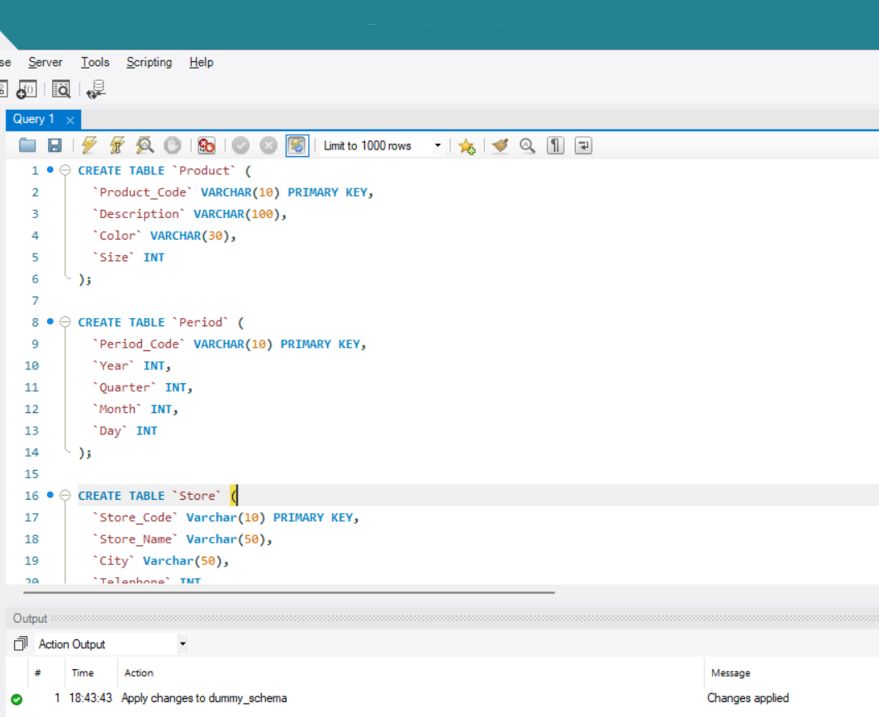

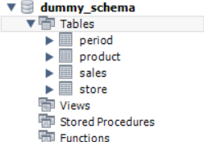

ii. In the top bar click on Database and in the dropdown

II. click on Reverse Engineer

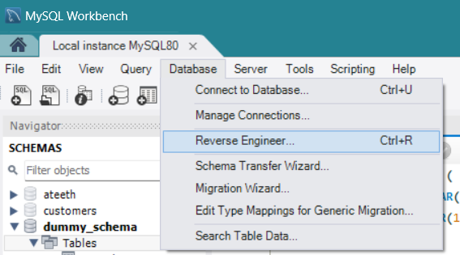

III. Fill in the following details regarding the database

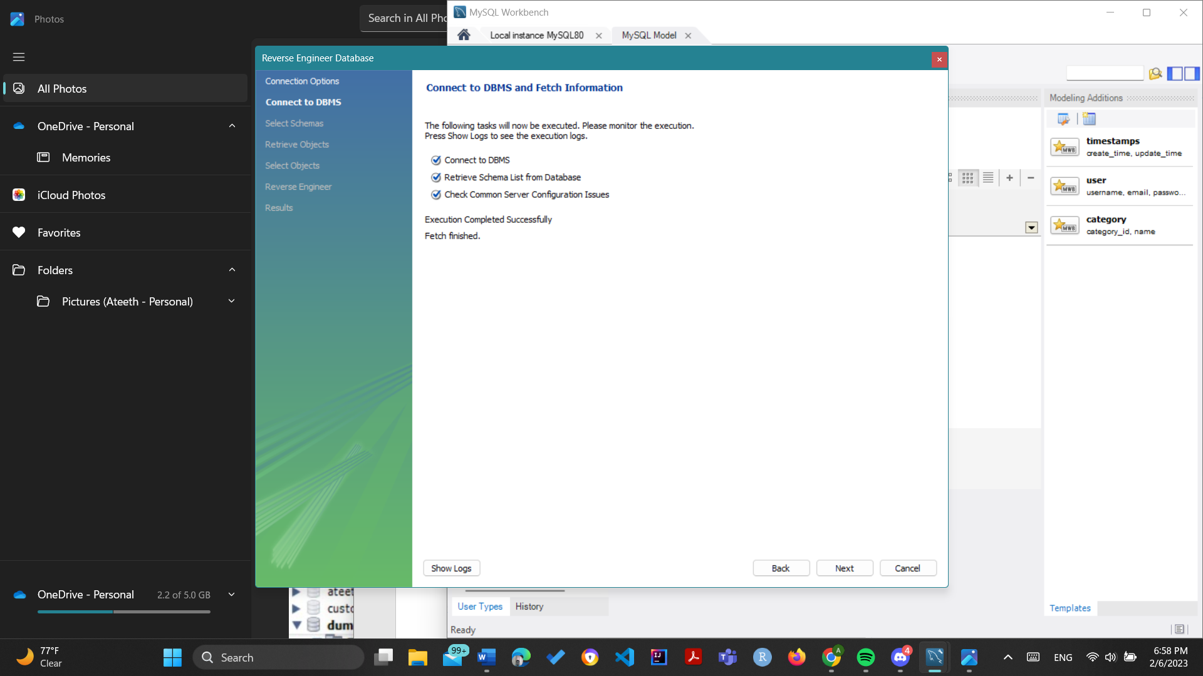

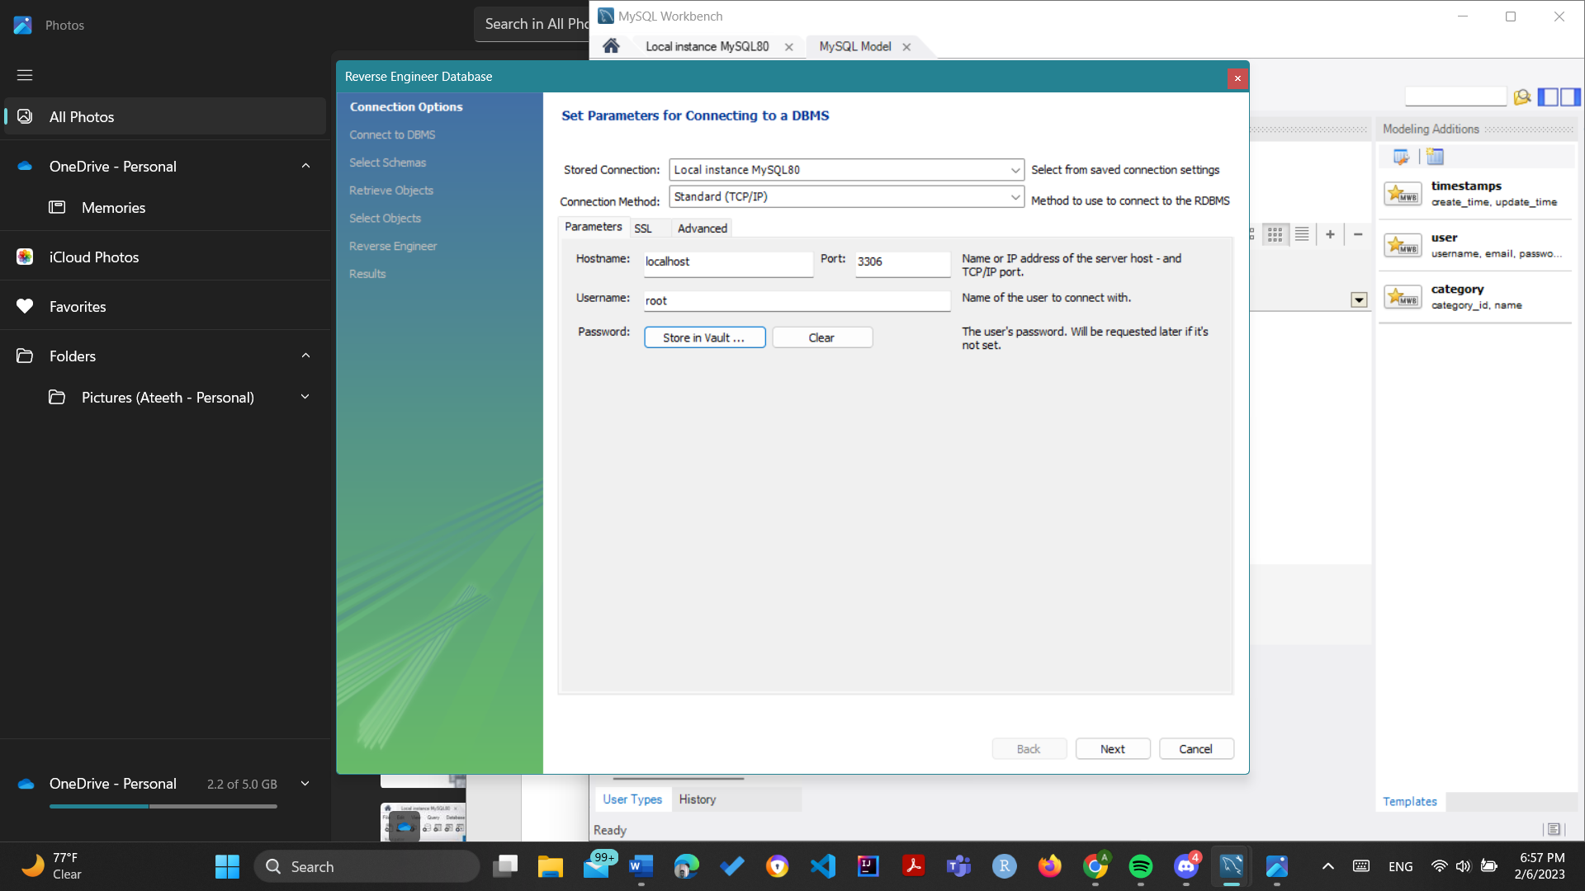IV. The following message will be visible

V. Select the schema to import and the tables that are to be imported then execute

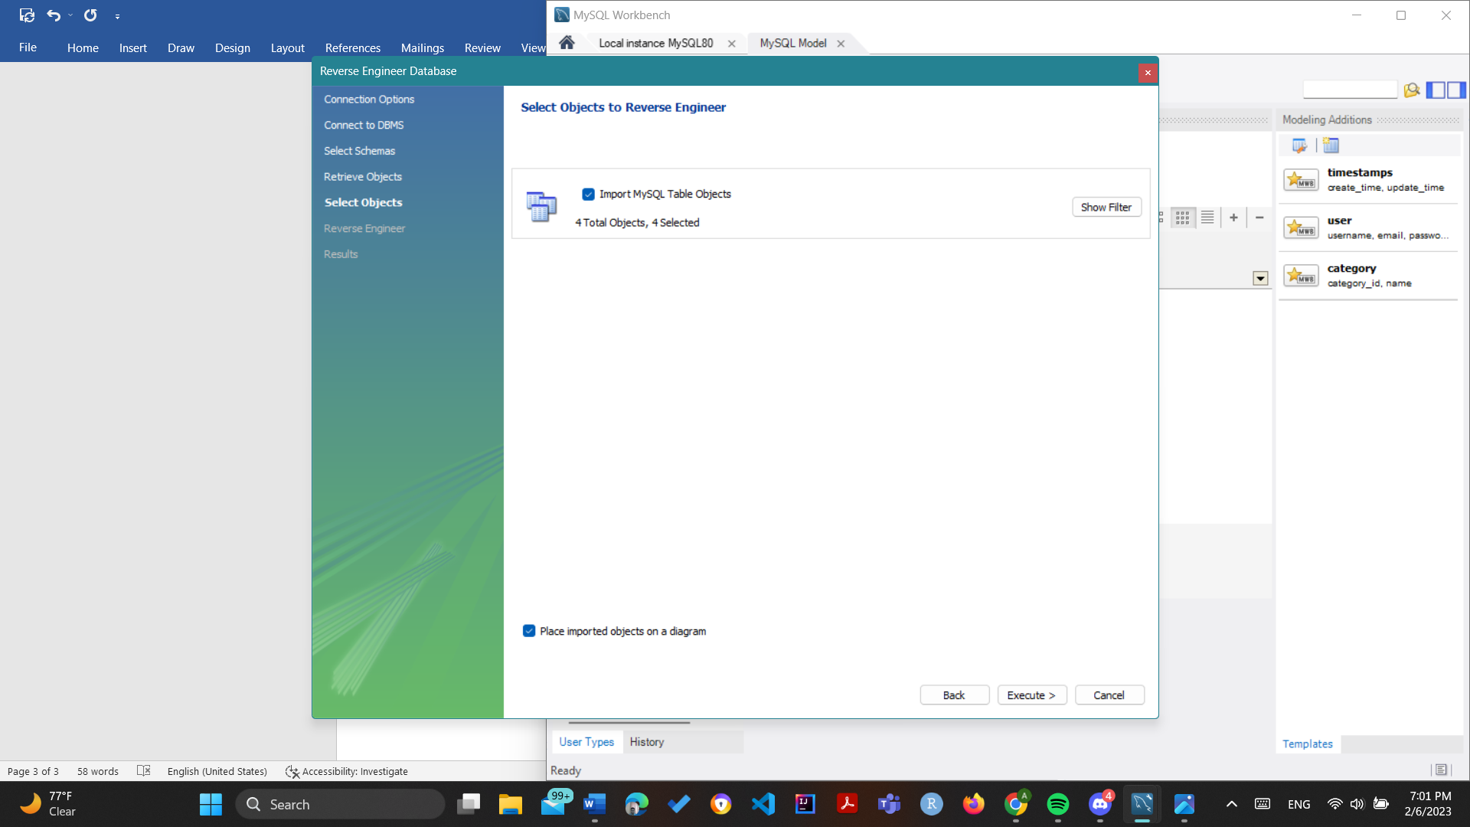

VI. The ER Diagram will be visible when Execute is clicked

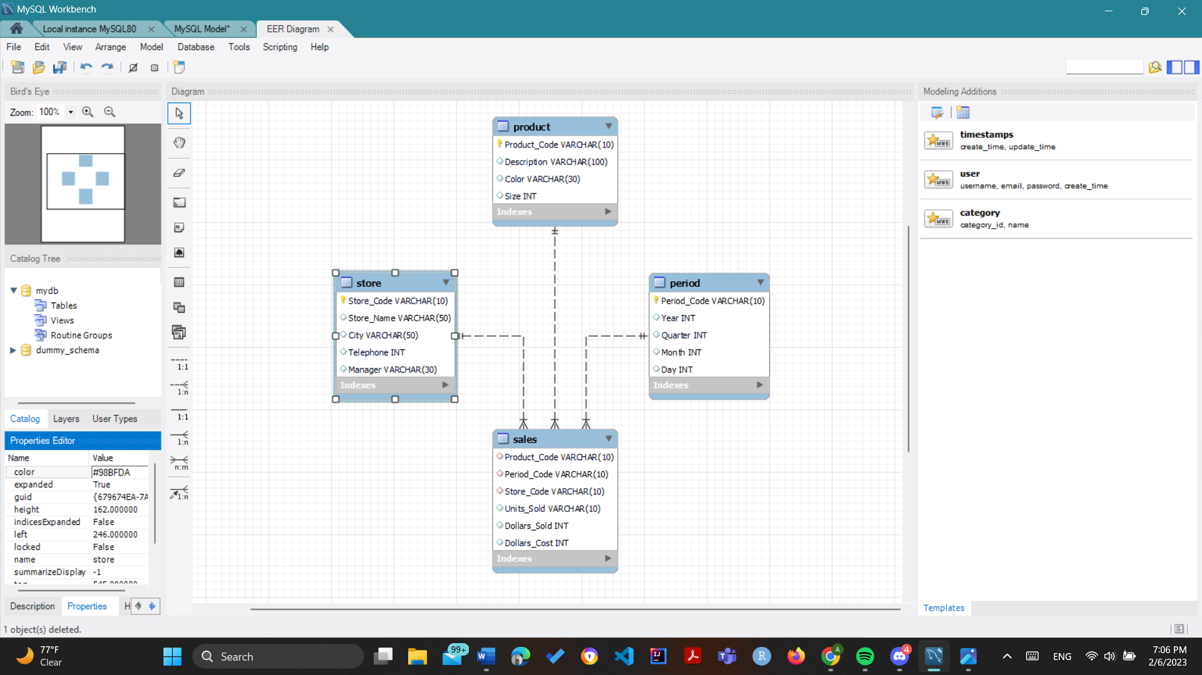

ii. Add a new table in the ER Diagram

Notice on the right side Modeling Additions

1. Click the first icon that is Open the table editor

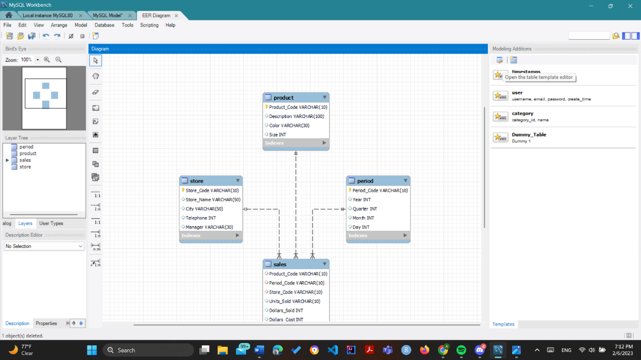

1. Click new template rename it by double clicking the row it appears and in the bottom part of the pop up all attributes needed can be added

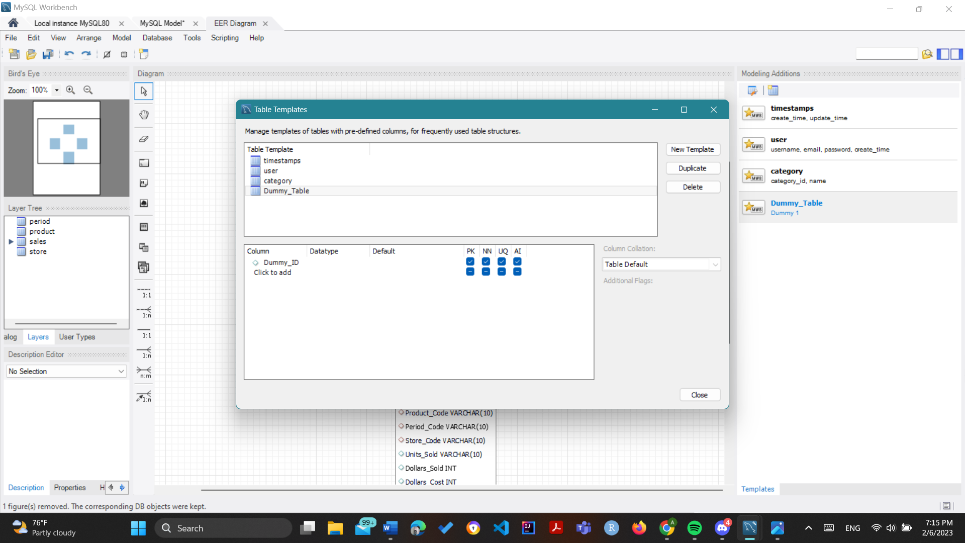

1. To add the table to the Schema on the right side modeling Additions just select the table name to be added it will be added in this case Dummy_Table is selected

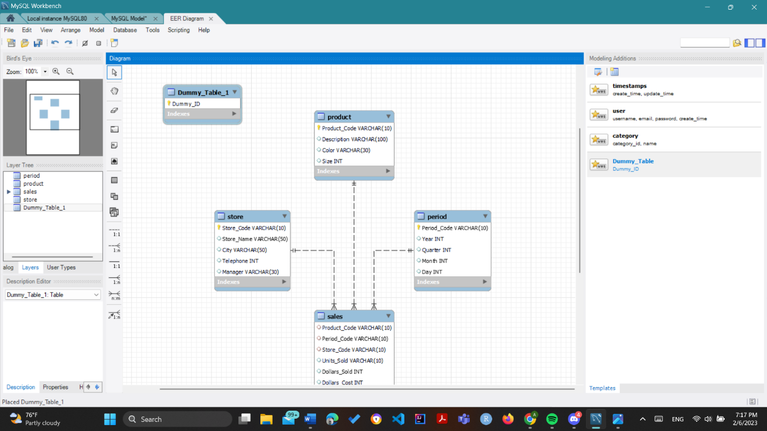

iii. Edit the tables i.e Add or Delete attributes

Note :- Sales table will be edited to add the attribute Dummy_ID as a foreign key referring Dummy_Table

1. Right click on table to be edited , click on Edit {Table_Name} / Edit {Table_Name} in new tab. Else even the table can just be double clicked .

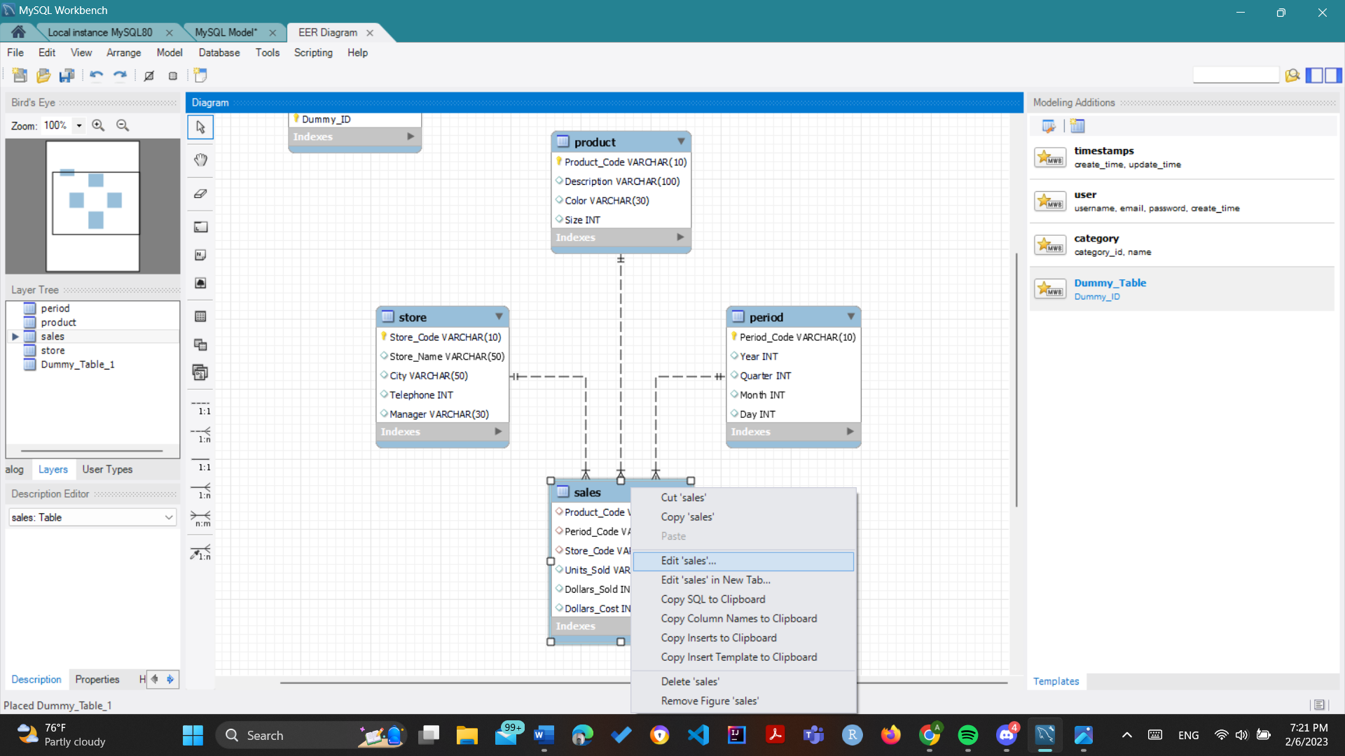

1. A tab will open at bottom of editor and the new attribute can be added from there

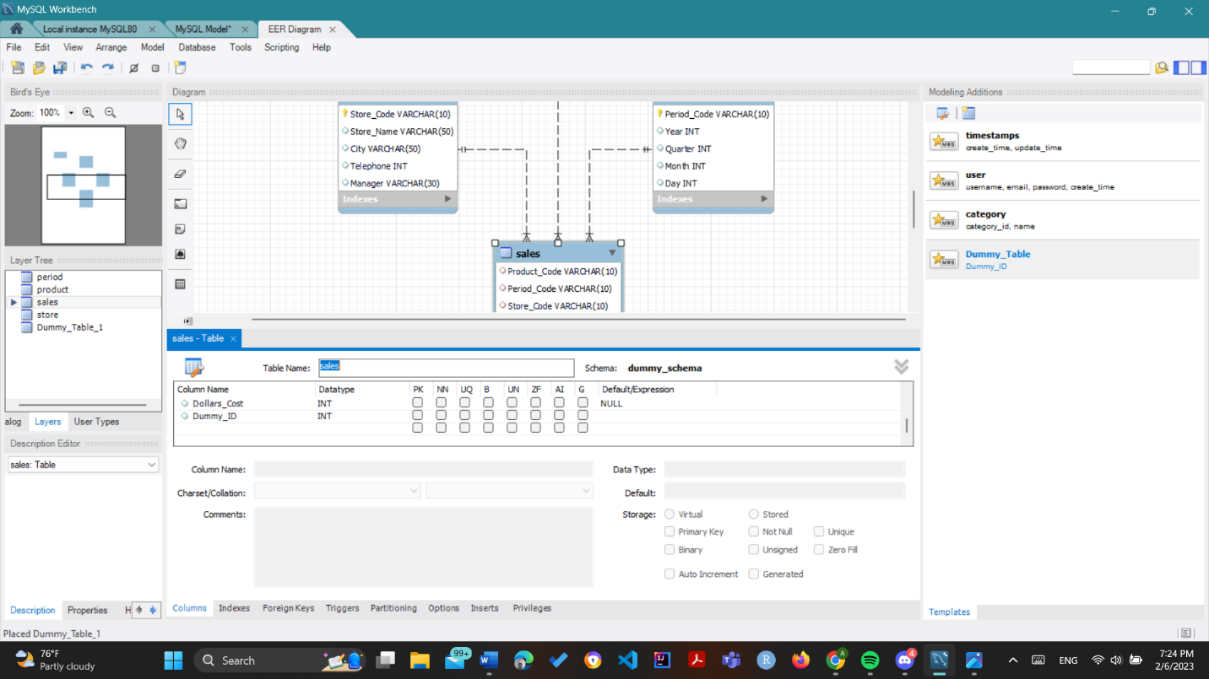

iv. Add a foreign key

1. See the bottom 4 options select one of them. In this example 1:n i.e 3rd last icon in above screenshot is selected

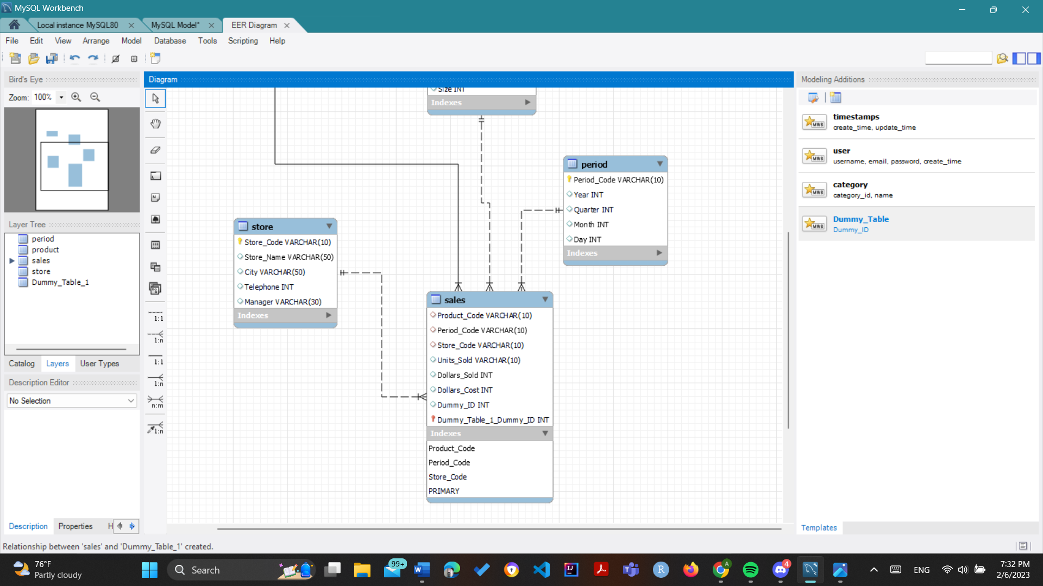

1. It will prompted to select the table that recieves foreign key. In this example Sales table selected

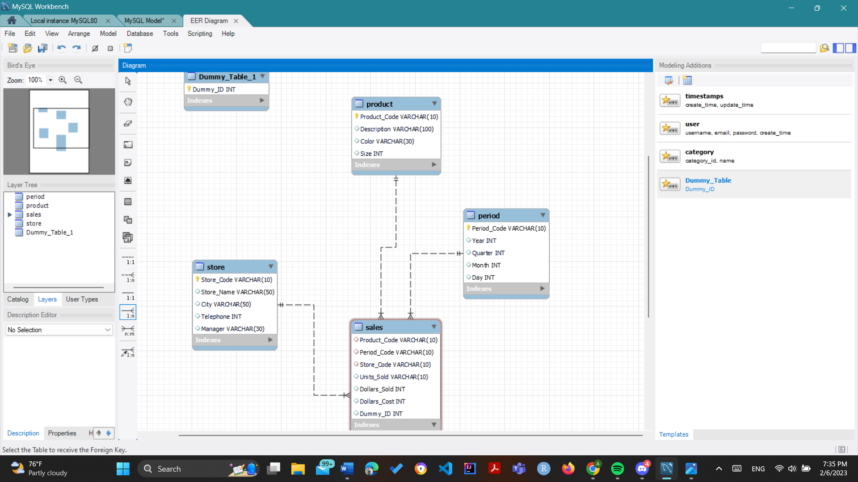

1. Then select Referenced table. In this example Dummy_Table selected.

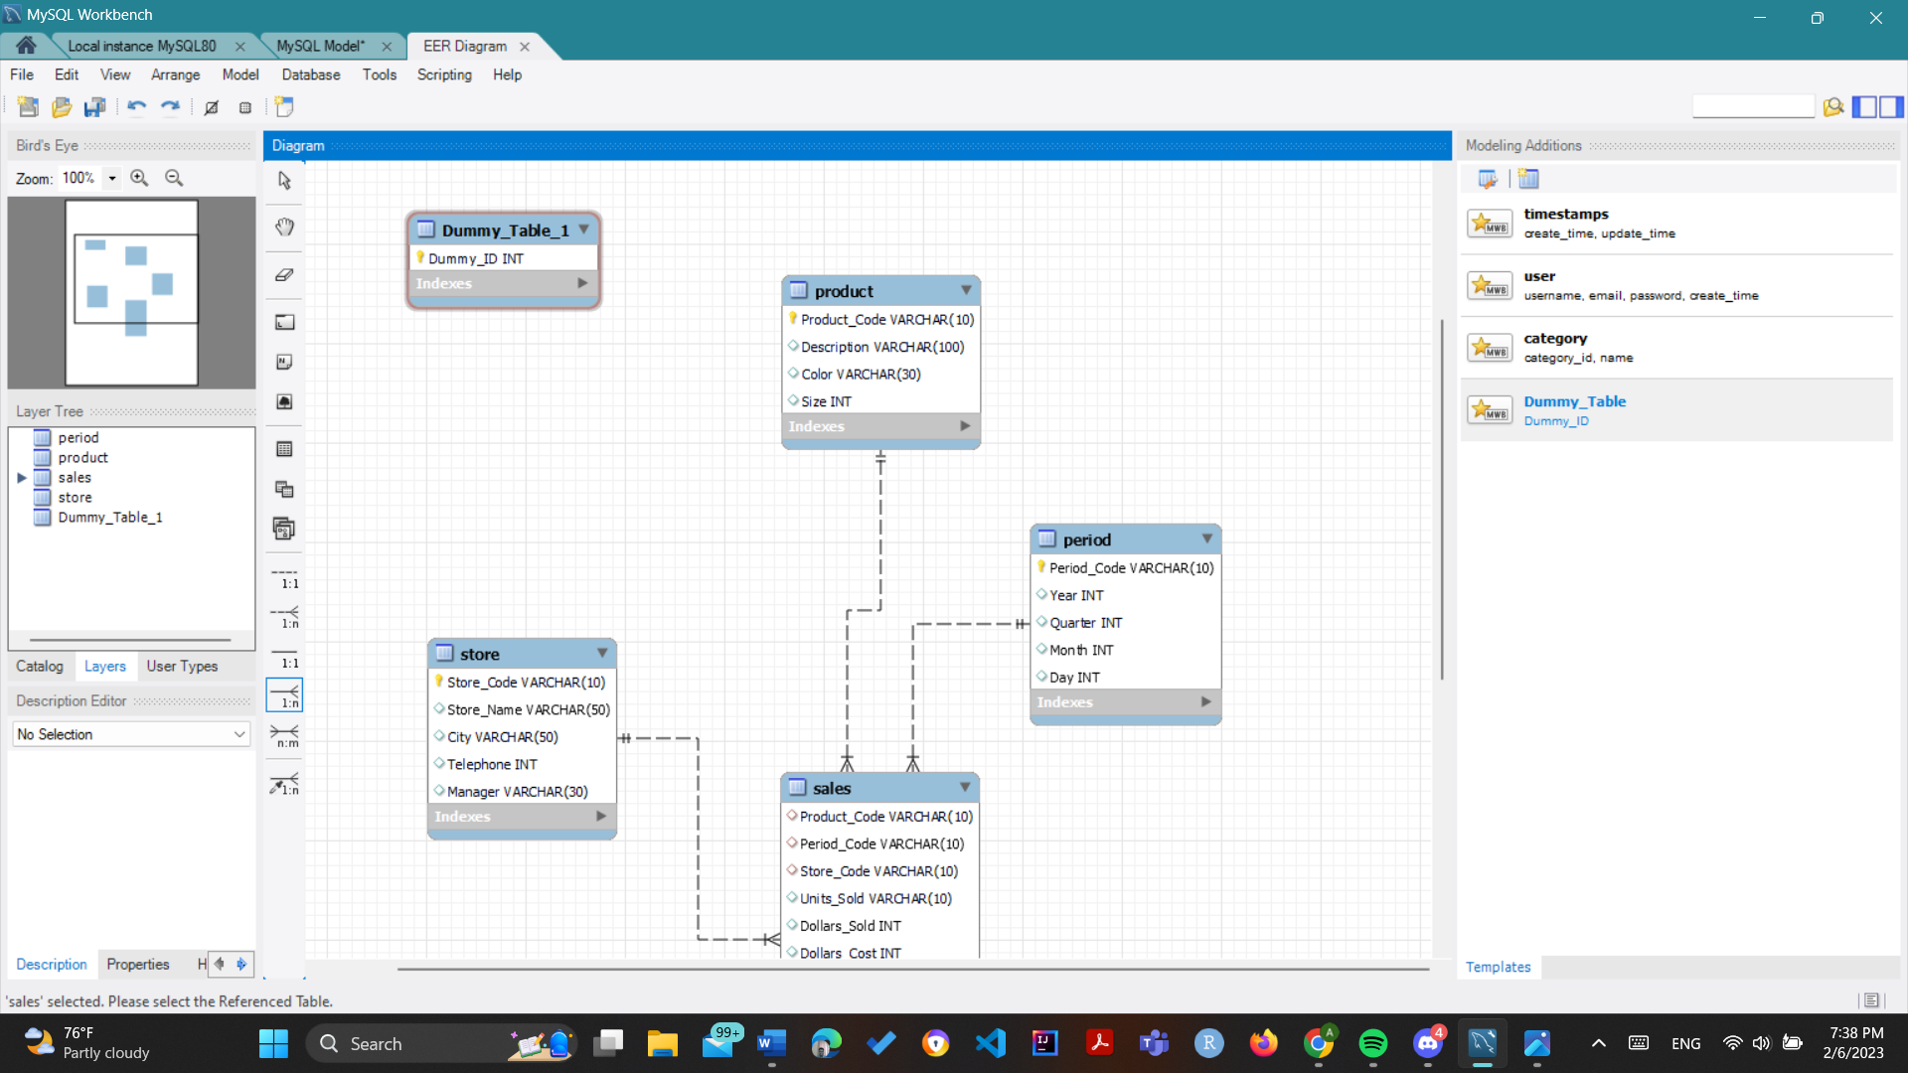

1. Then the relationship is drawn , in this case between Dummy_Table and Sales

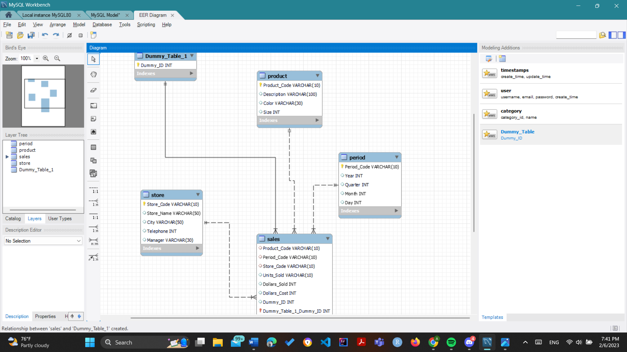v. Delete a table or attribute

I. Right click the table and click option delete {Table_Name}

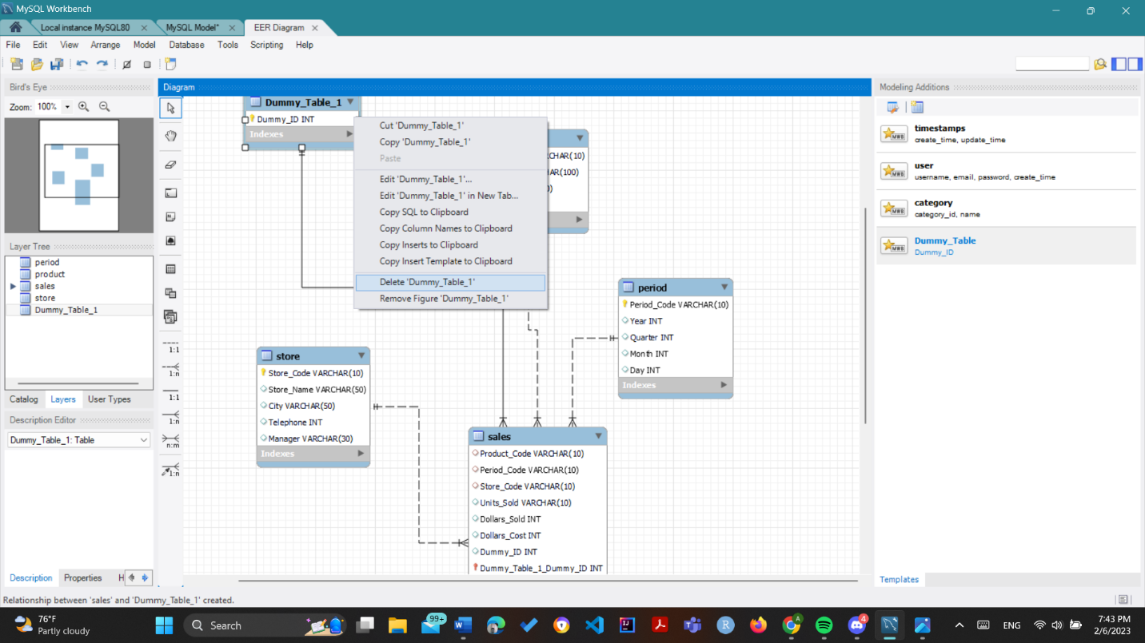

1. To delete attribute just how attribute was added double click table / right click table and click edit , then just click the attribute row in the tab that opens at the bottom , right click and select delete selected.

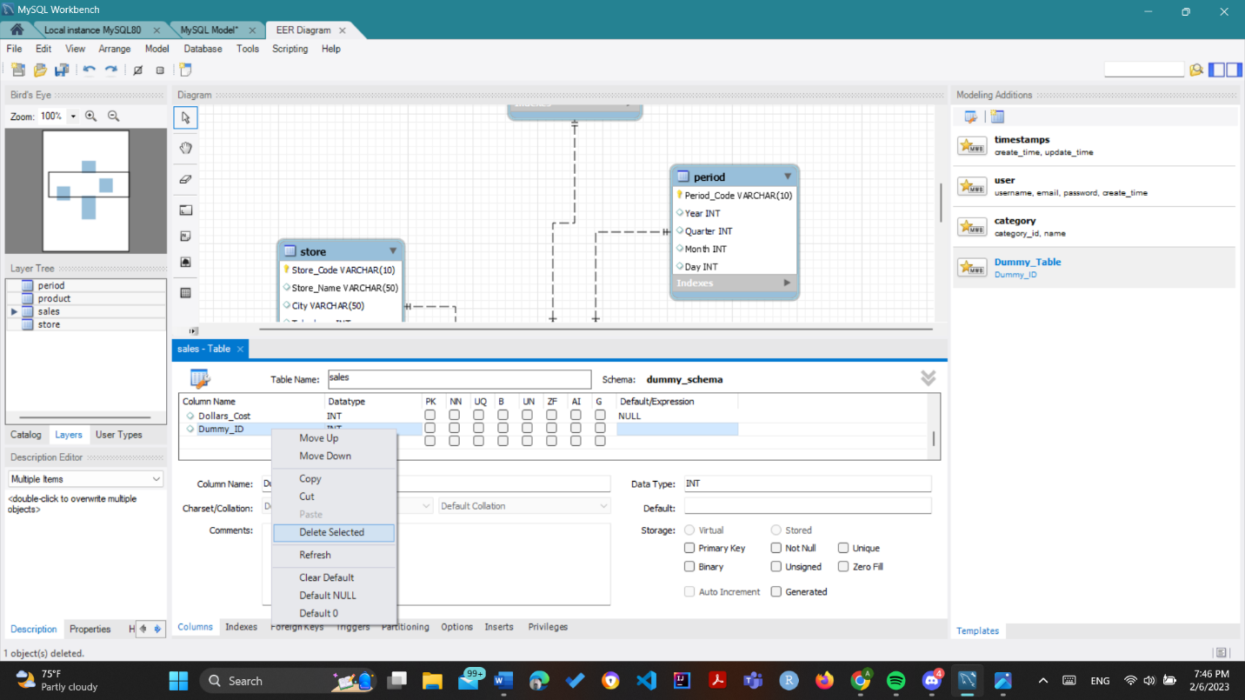

vi. Change the color of a table

Note : store table is considered at first for this example

1. Click the table whose color is to be changed and at bottom left click Properties

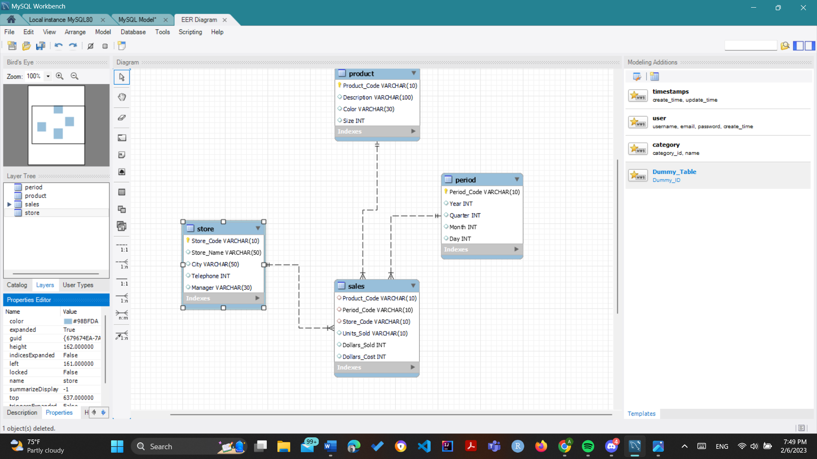

1. Change the color column value to any hexadecimal color. Note that store table has a new color which is light green after changing the color value. Note the color is now #17fc03

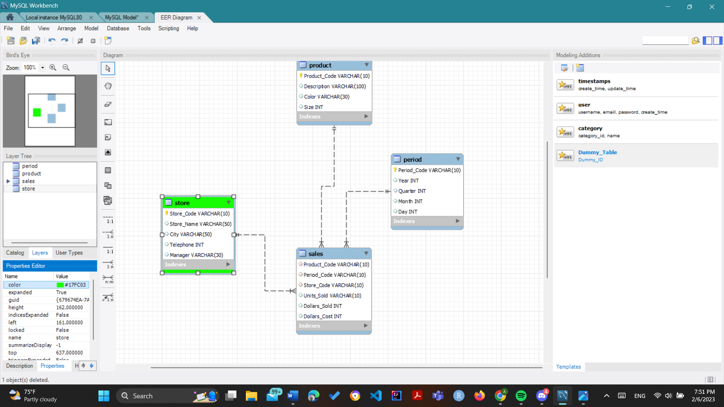

1. Now the color of all tables can be changed similarly

Product - #FC0303

Store - #17FC03

Sales – #03FCC6

Period - #0341FC

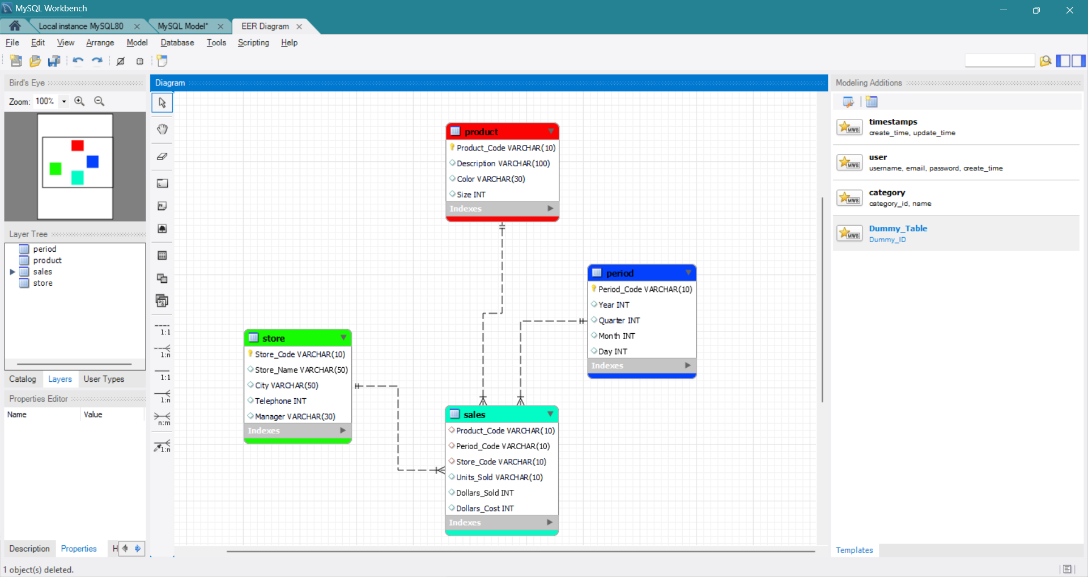

vii. Note when hovering over a relationship line , the color of relationship line and the attributes involved in the relationship change dynamically as seen in the below example.

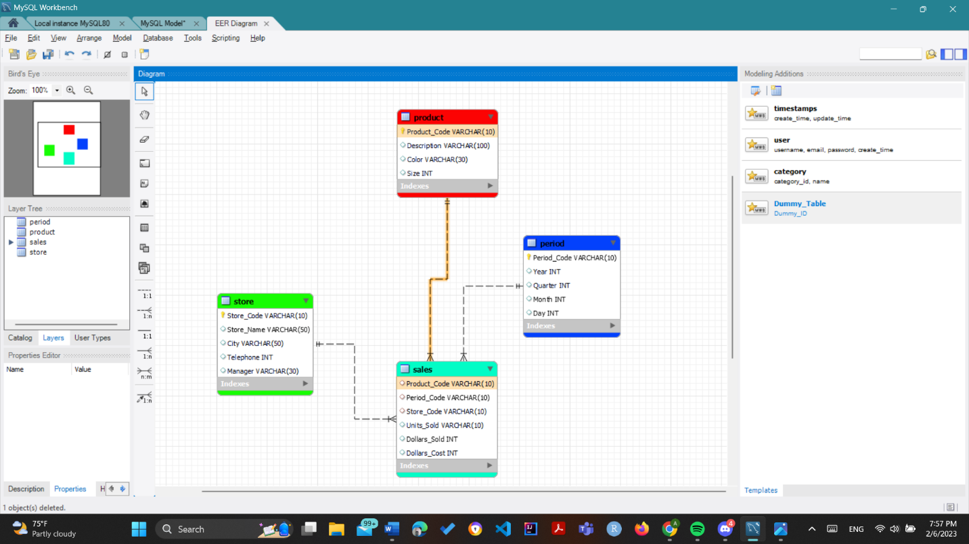

viii. Export the schema diagram i.e Forward Engineering

1. Click Database in top menu then Forward Engineering

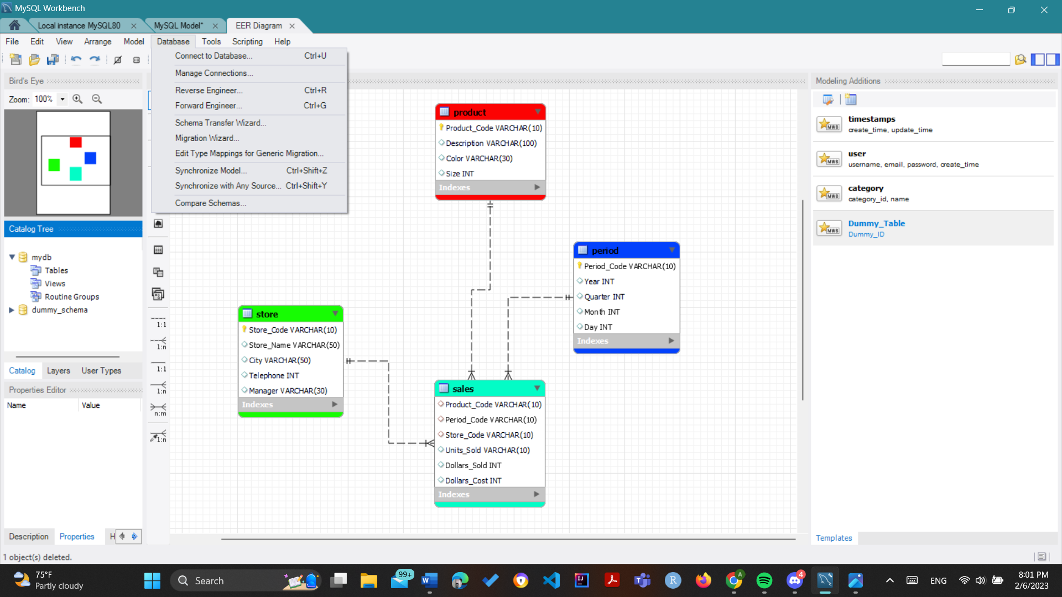

1. Fill Required details

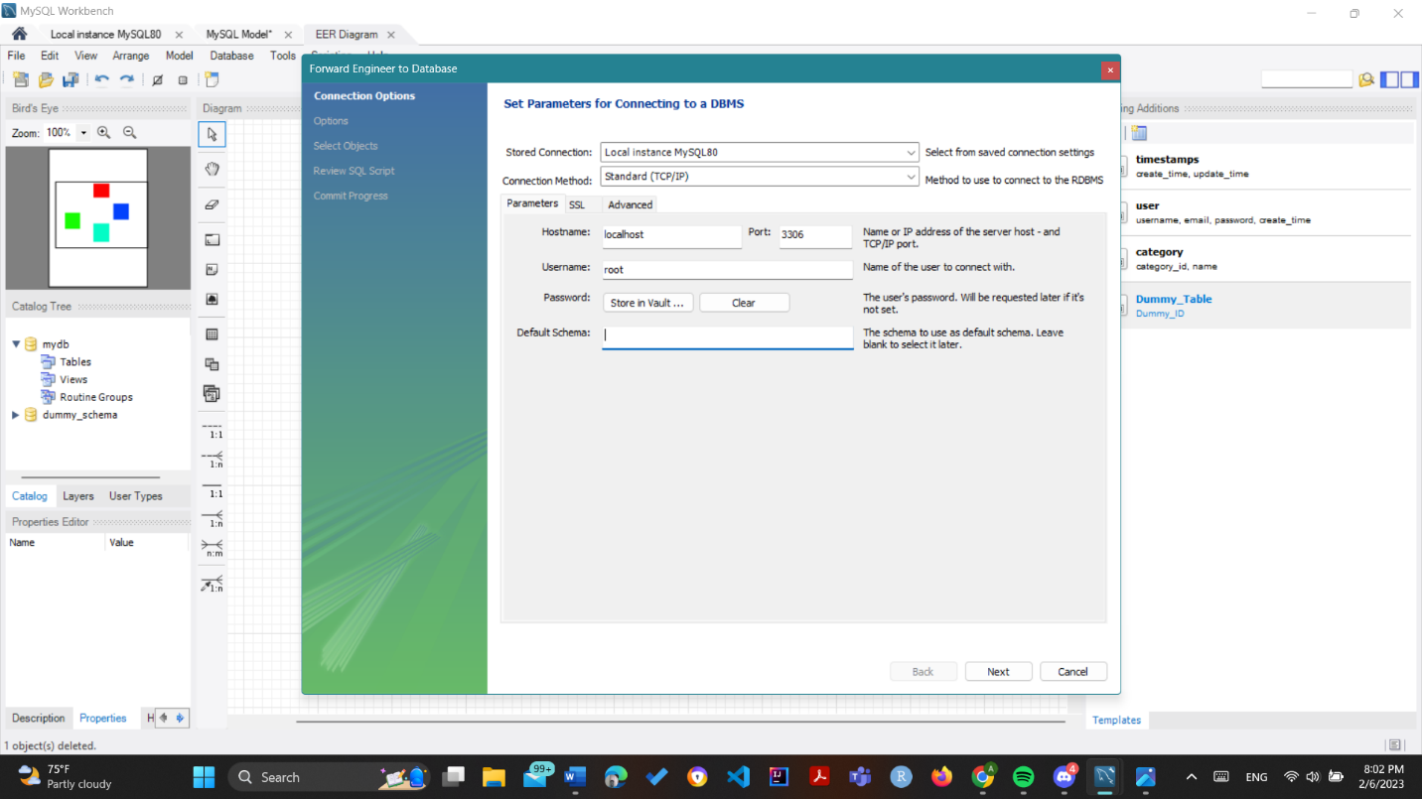

1. Select any options if needed

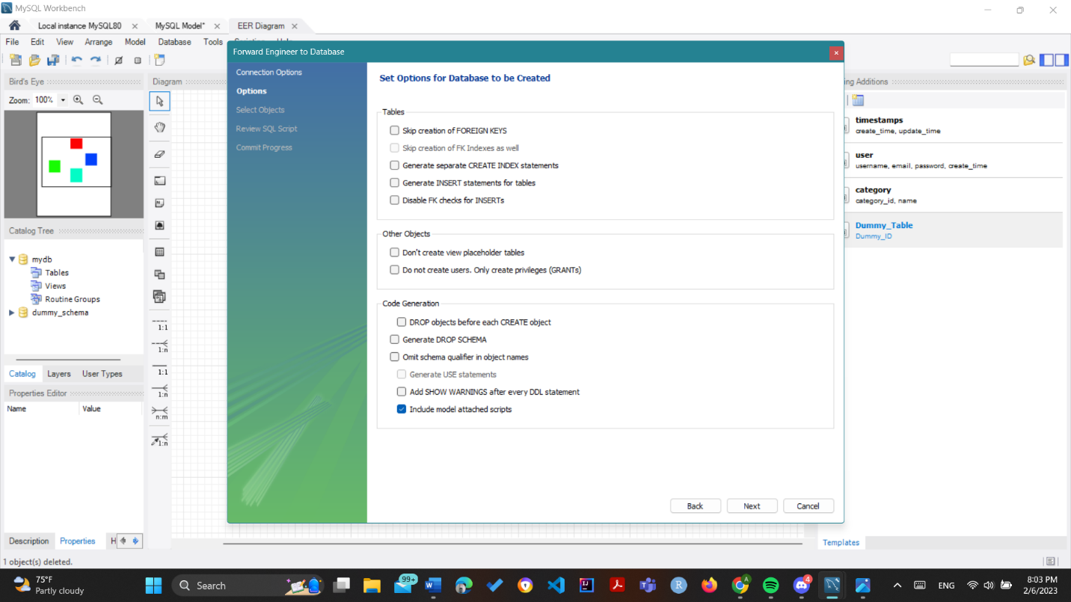

1. Select any options if needed

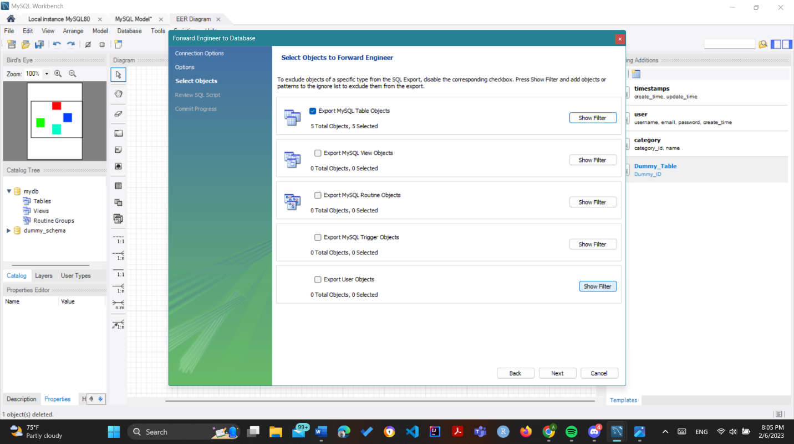

1. SQL Script is visible and can be saved to a file or else it can be copied to clipboard

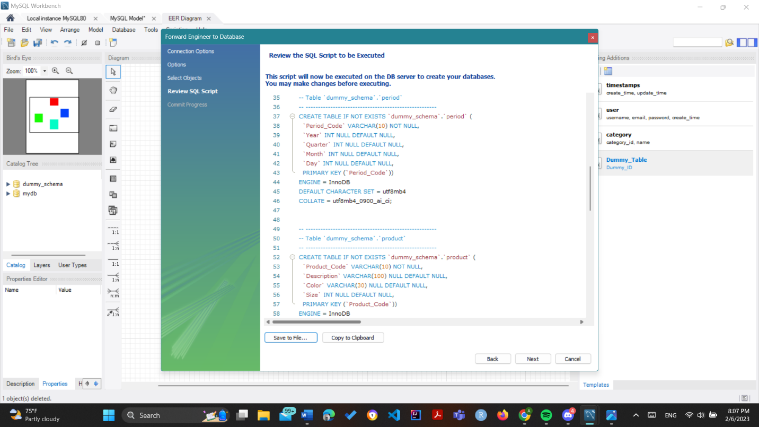

Then the code is executed and the code can be saved in clipboard or in a file

4. Hackolade

i. Import a mongodb file as json

I. Go to tools , Reverse Engineer and JSON or YAML file

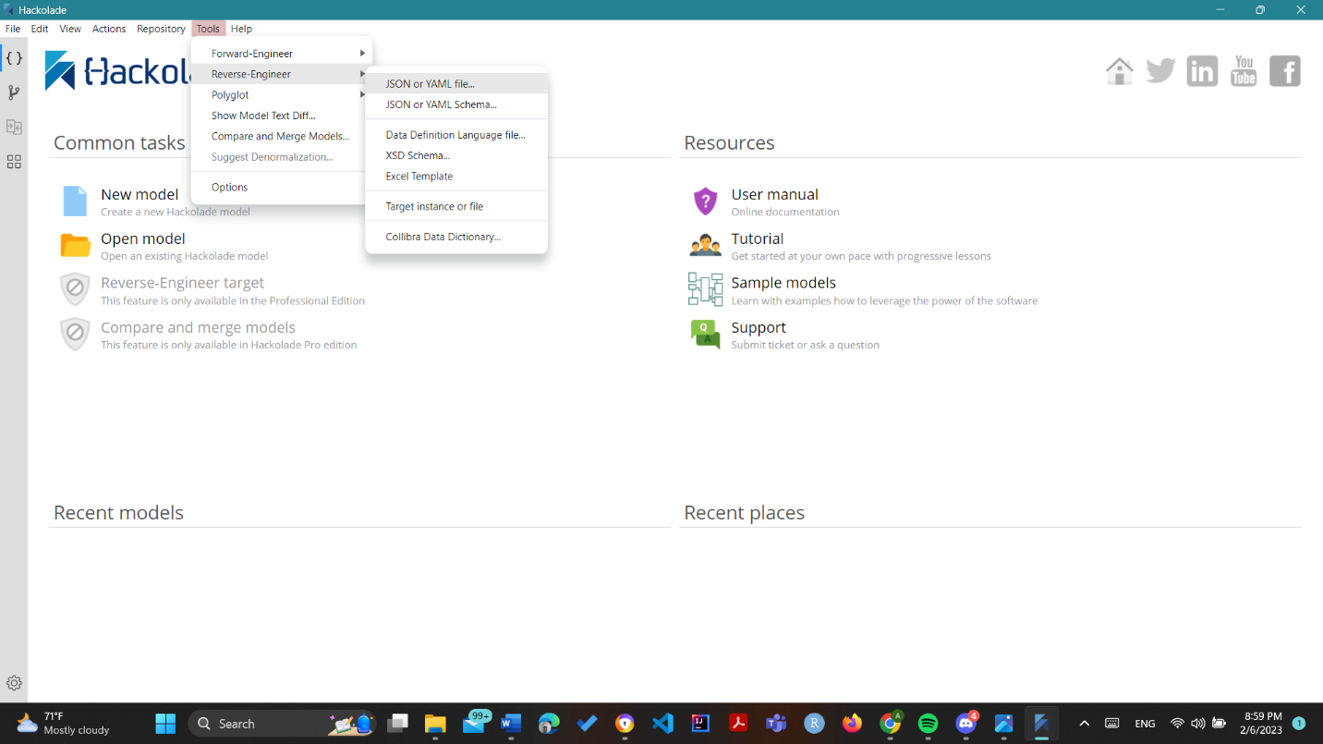

1. Select MongoDB and version then Create

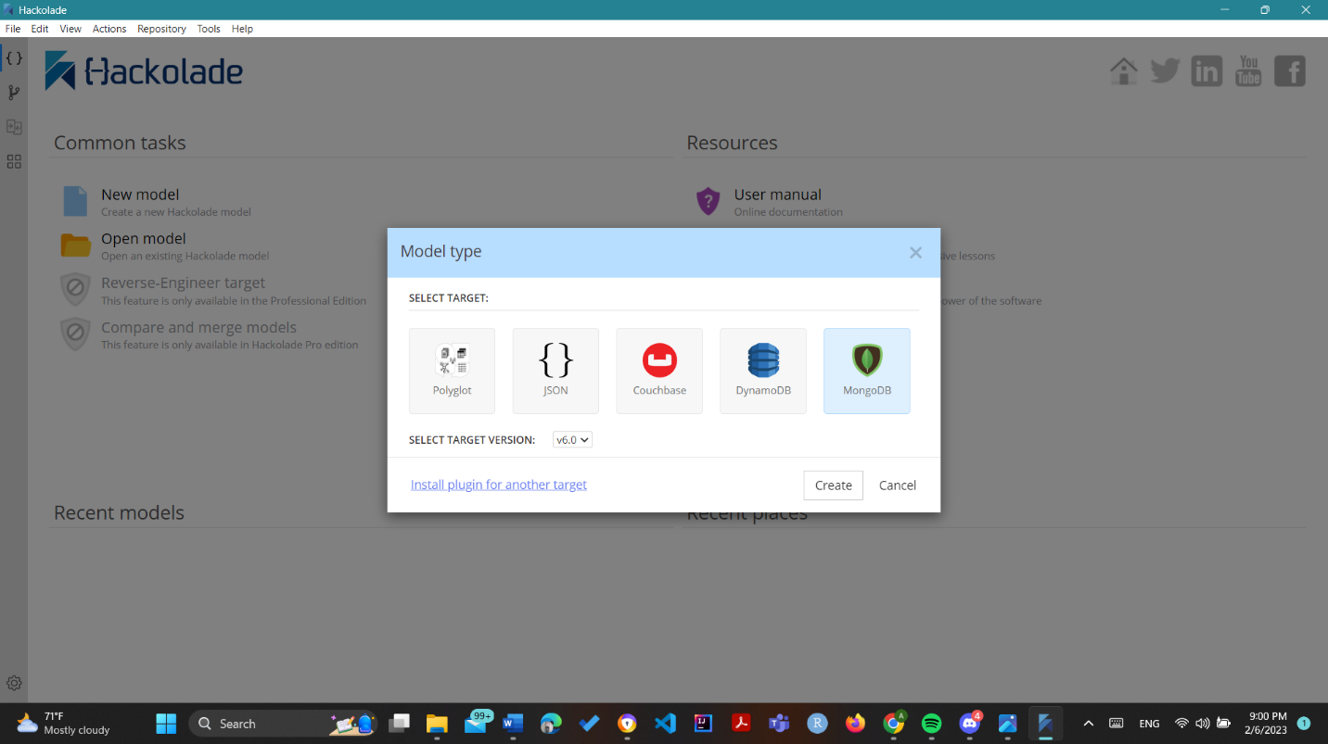

1. Select the file to import

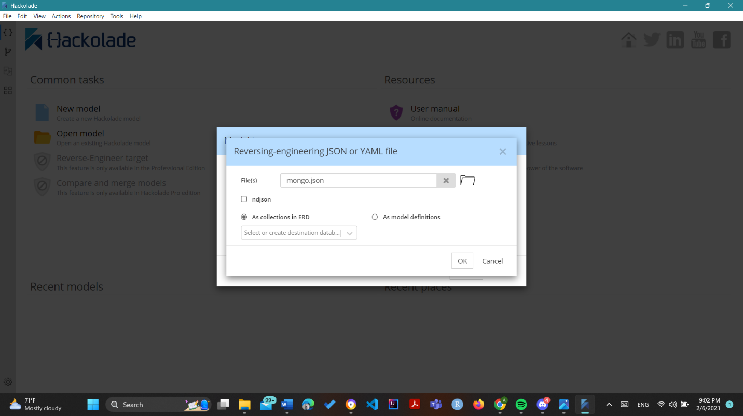

1. The schema diagram is generated

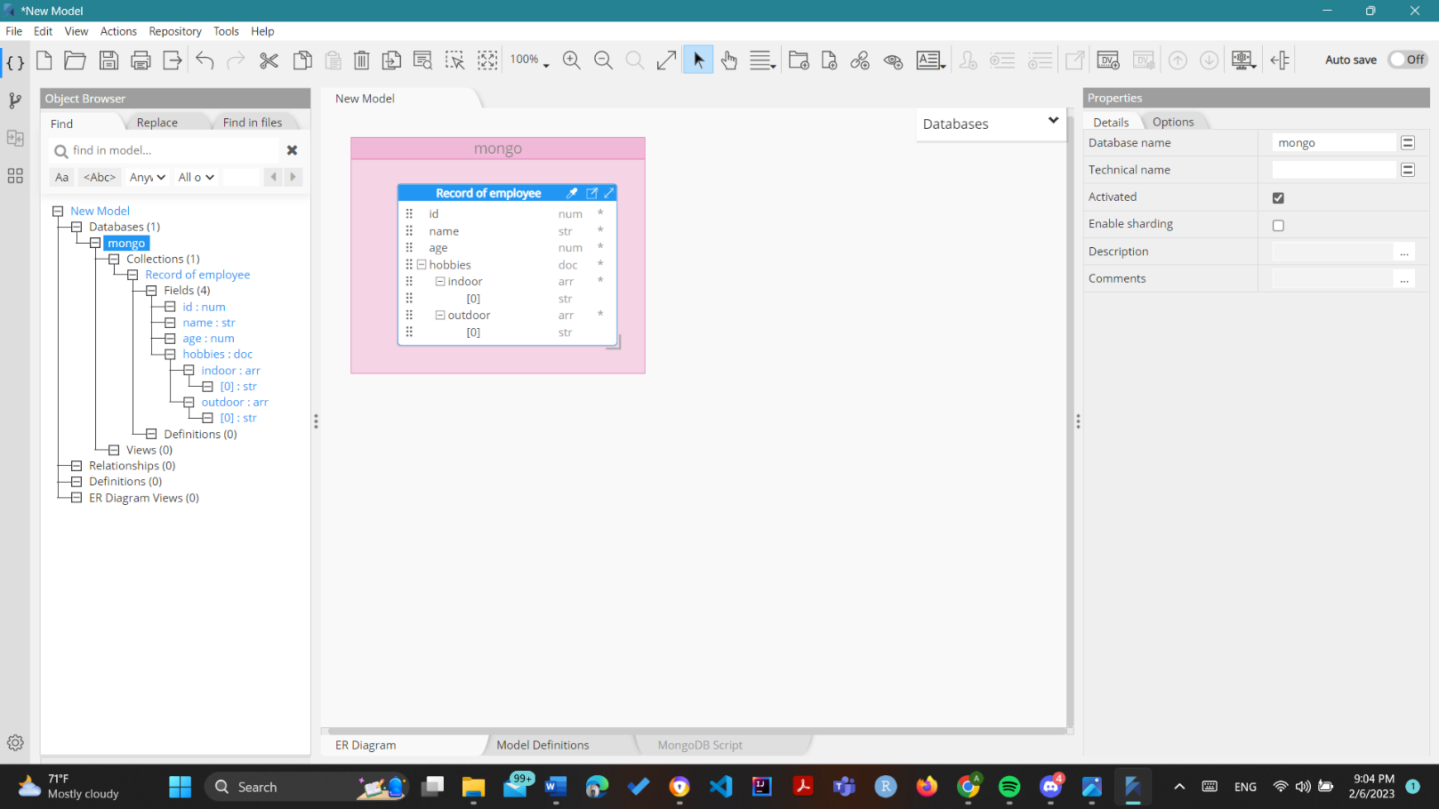

ii. Change color of table

1. 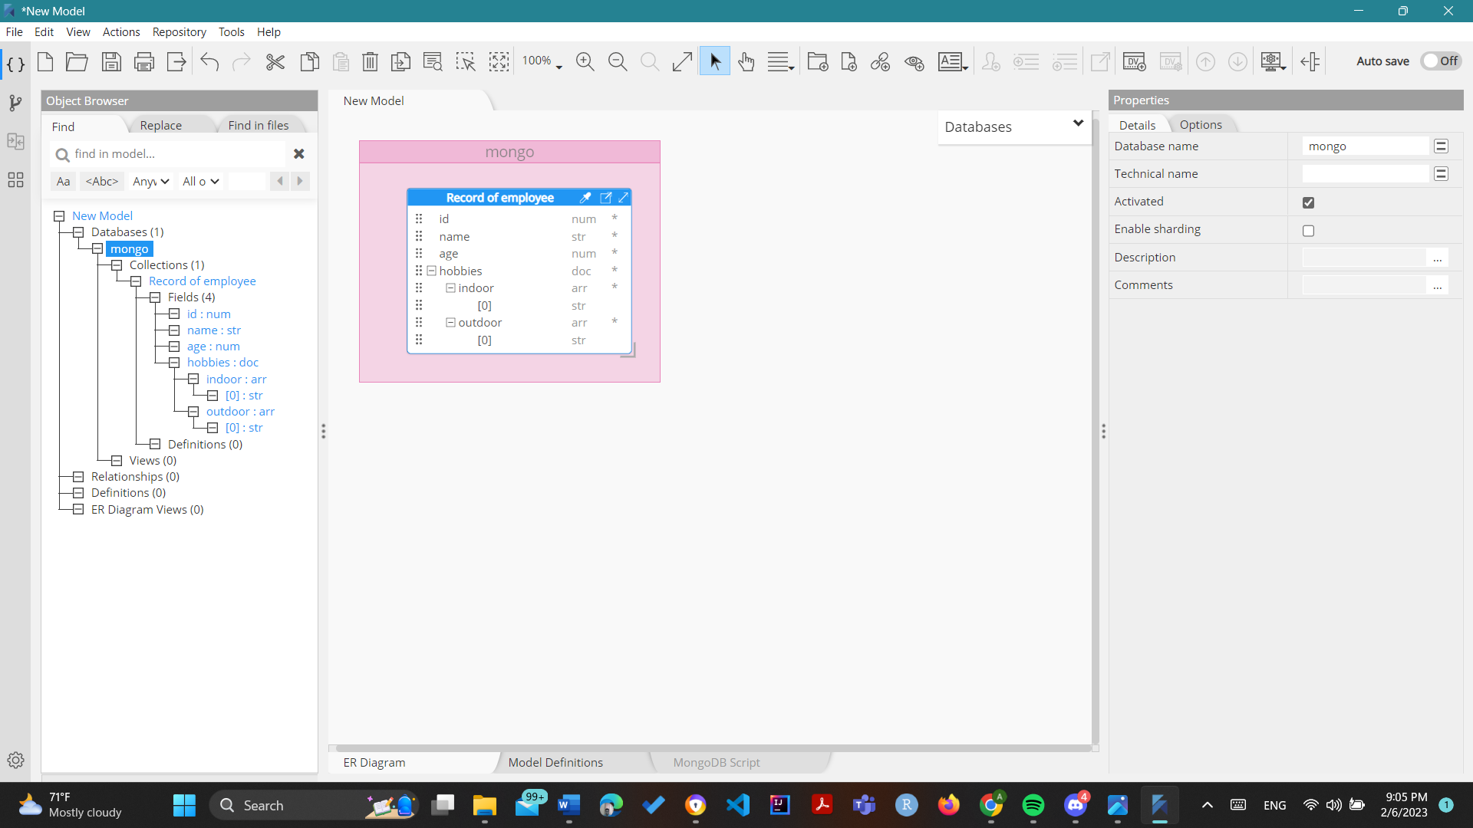Just select the first icon for custom color picker beside the table name ie just beside Record of Employee in this case
2. Select the color from options available
3. 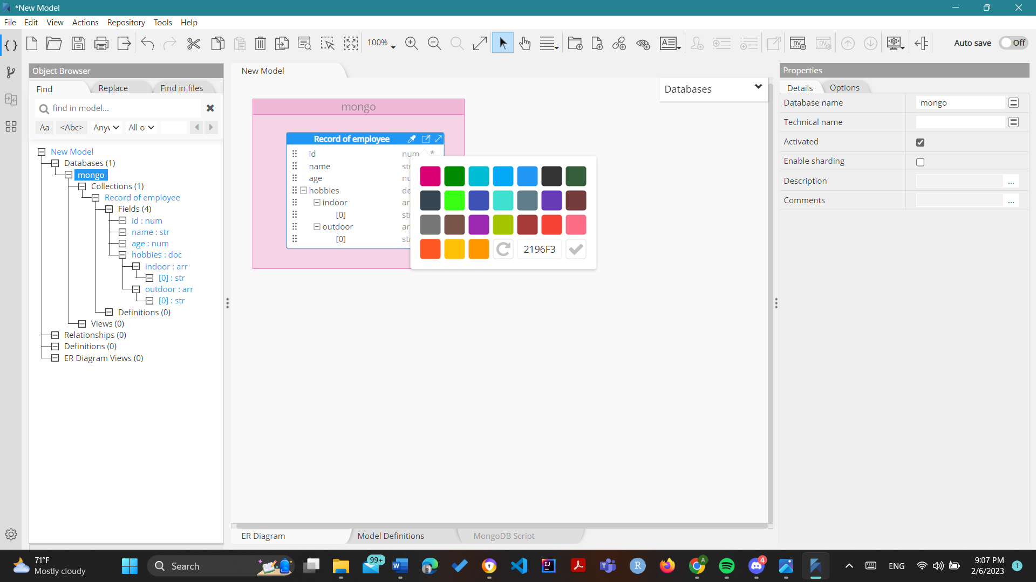Note that the color of table is changed to light green

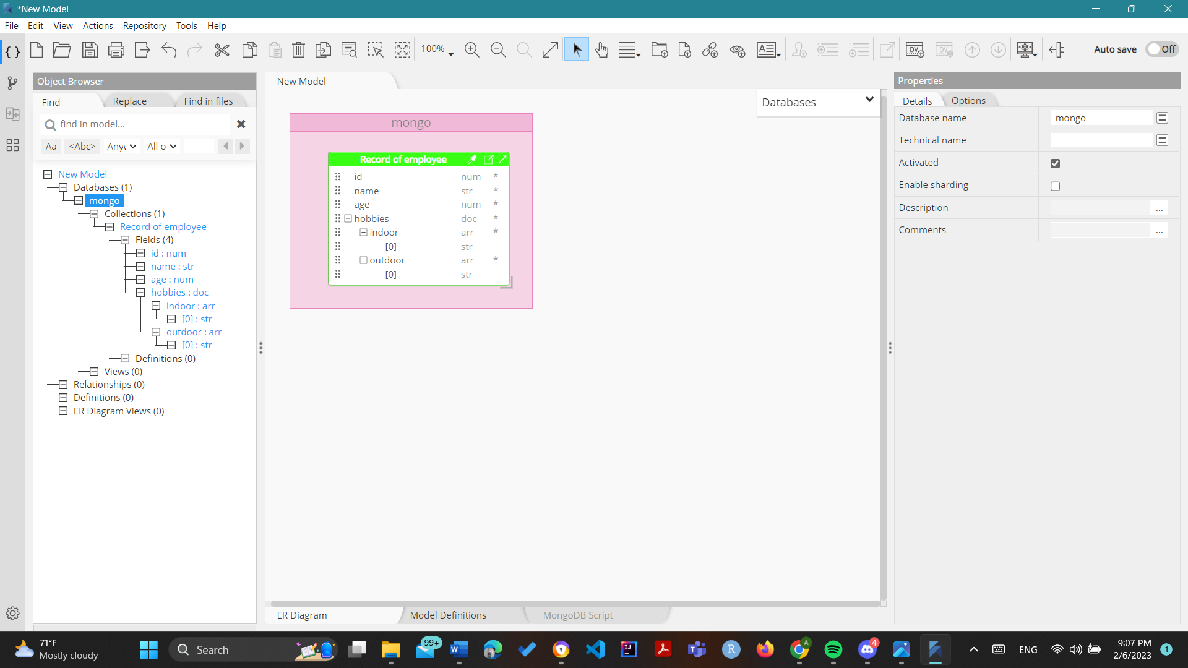iii. Add collection

1. Right click database and click add collection

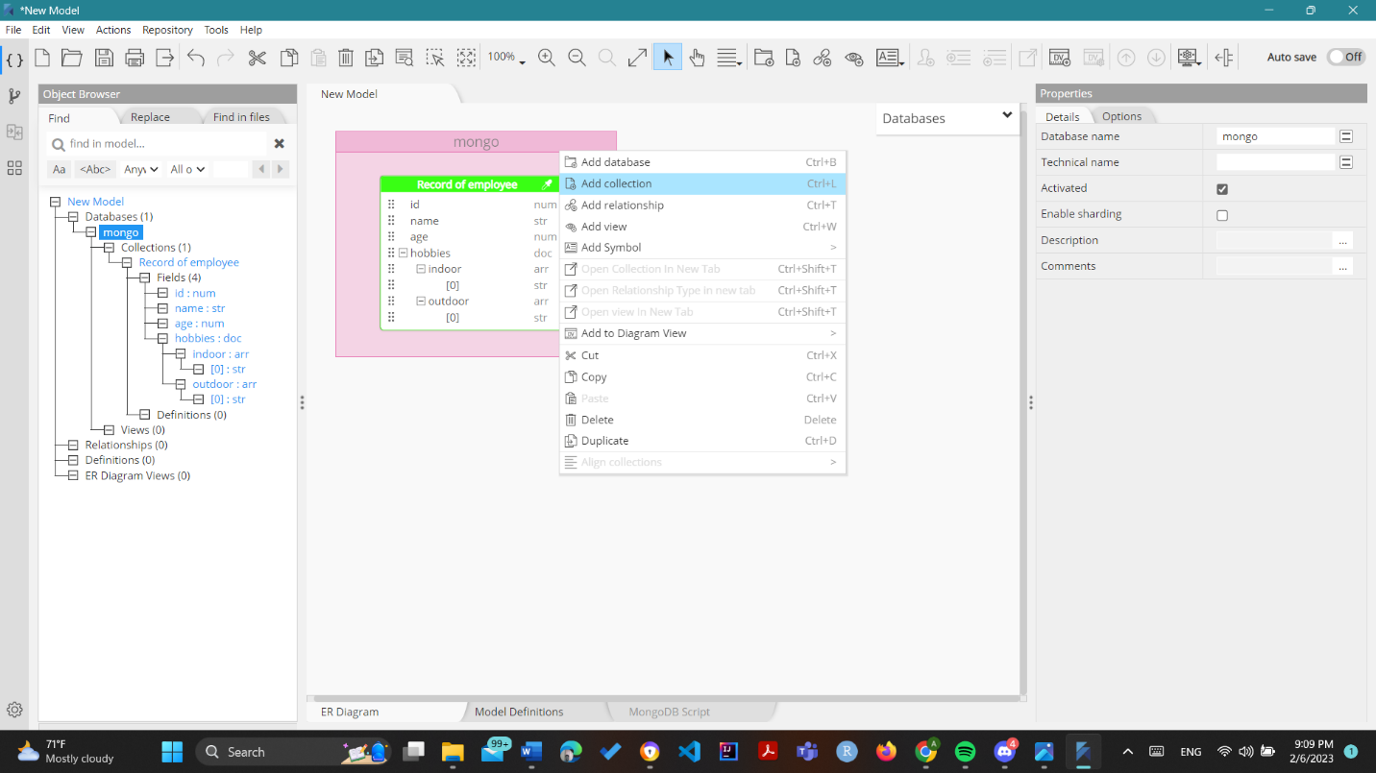

1. Note that a new collection is created

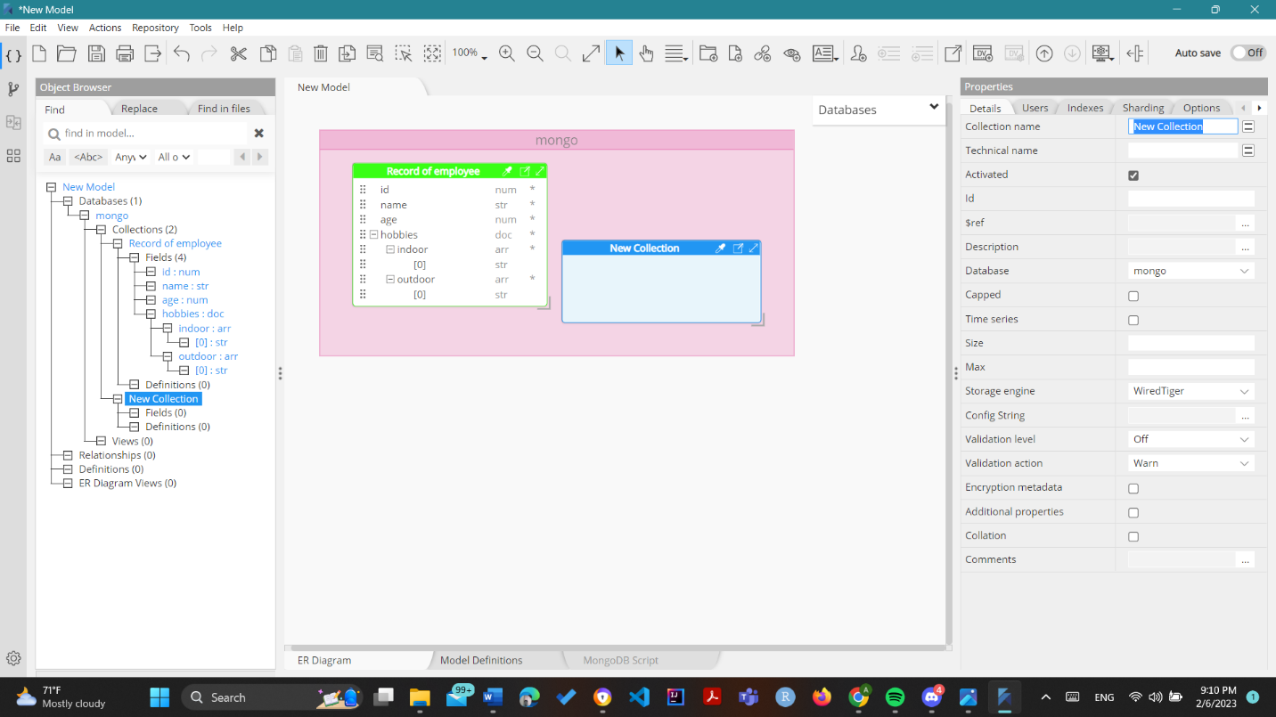

iv. Rename a collection

1. Click the collection to edit in this case New Collection as of now and rename it from the right bar in this case the collection is renamed to Dummy

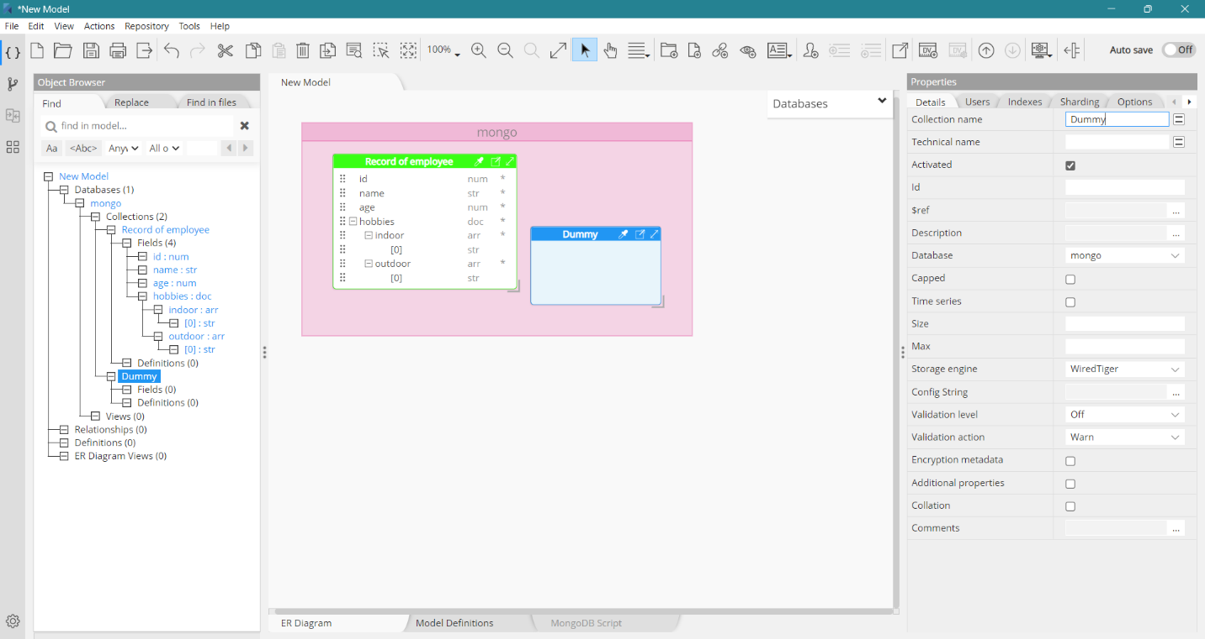

v. Add fields to a collection

I. Right click the collection to which the field is to be added in this case Dummy and field and string

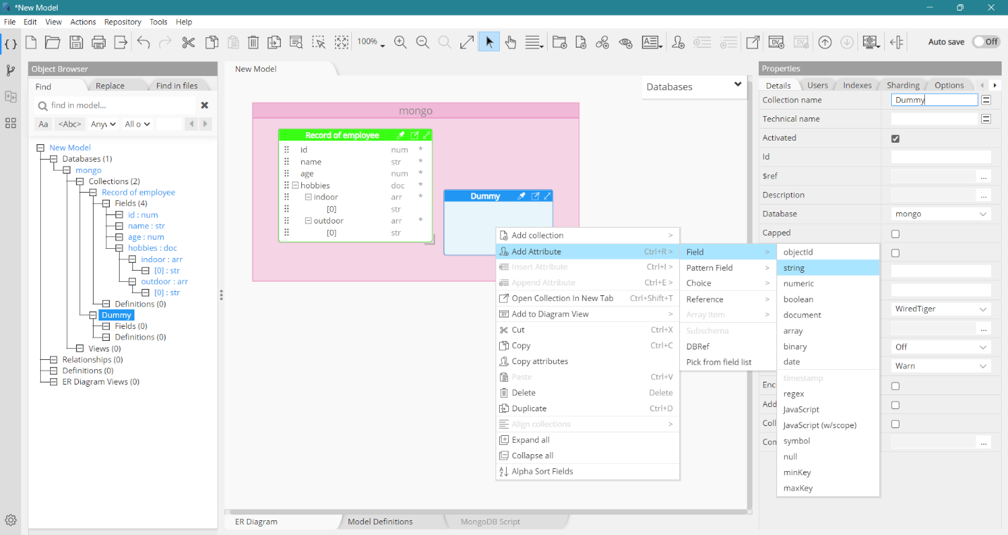

1. Edit the name in the right bar , in this example name of field is name and is an str

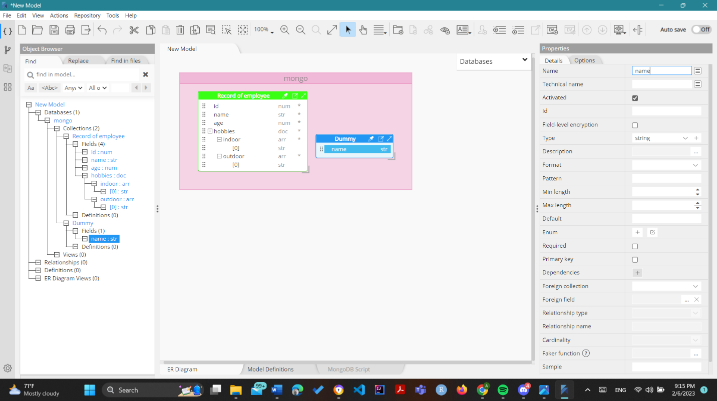

vi. Add relationship

1. Right click database and click add relationship
2. 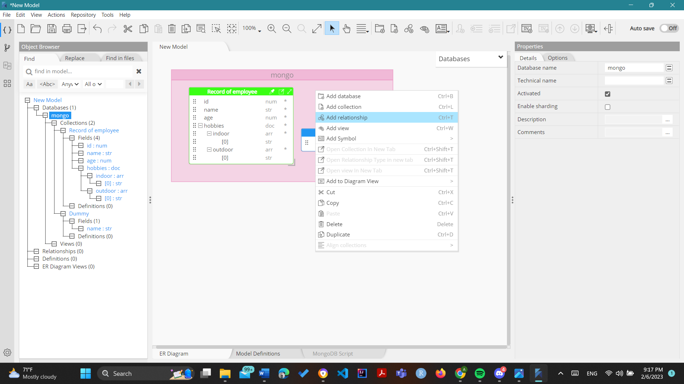Edit relationship details in the right hand bar , fill all details and the relationship is shown in the schema

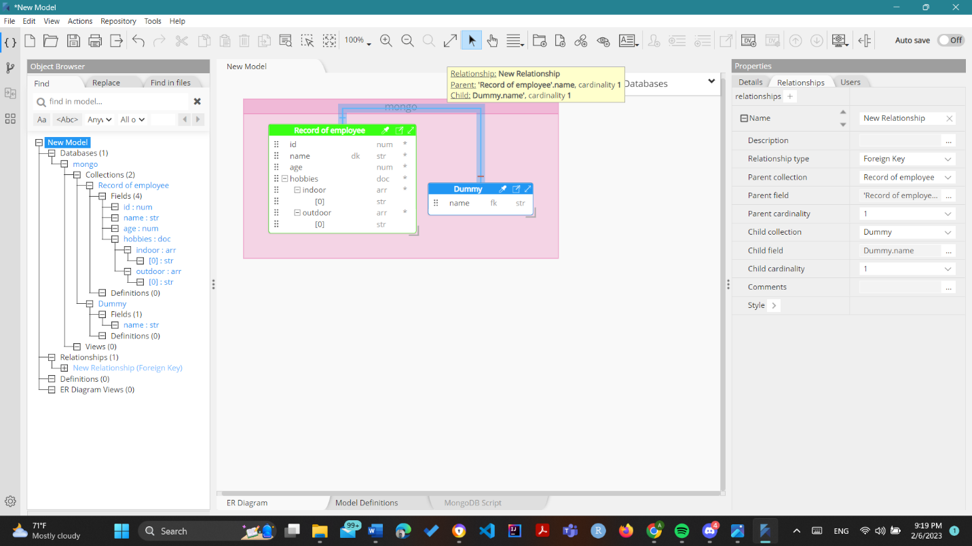

vii. Delete field

Note : In this example age field of Record of employee collection is deleted

1. Right click attribute to be deleted and click delete

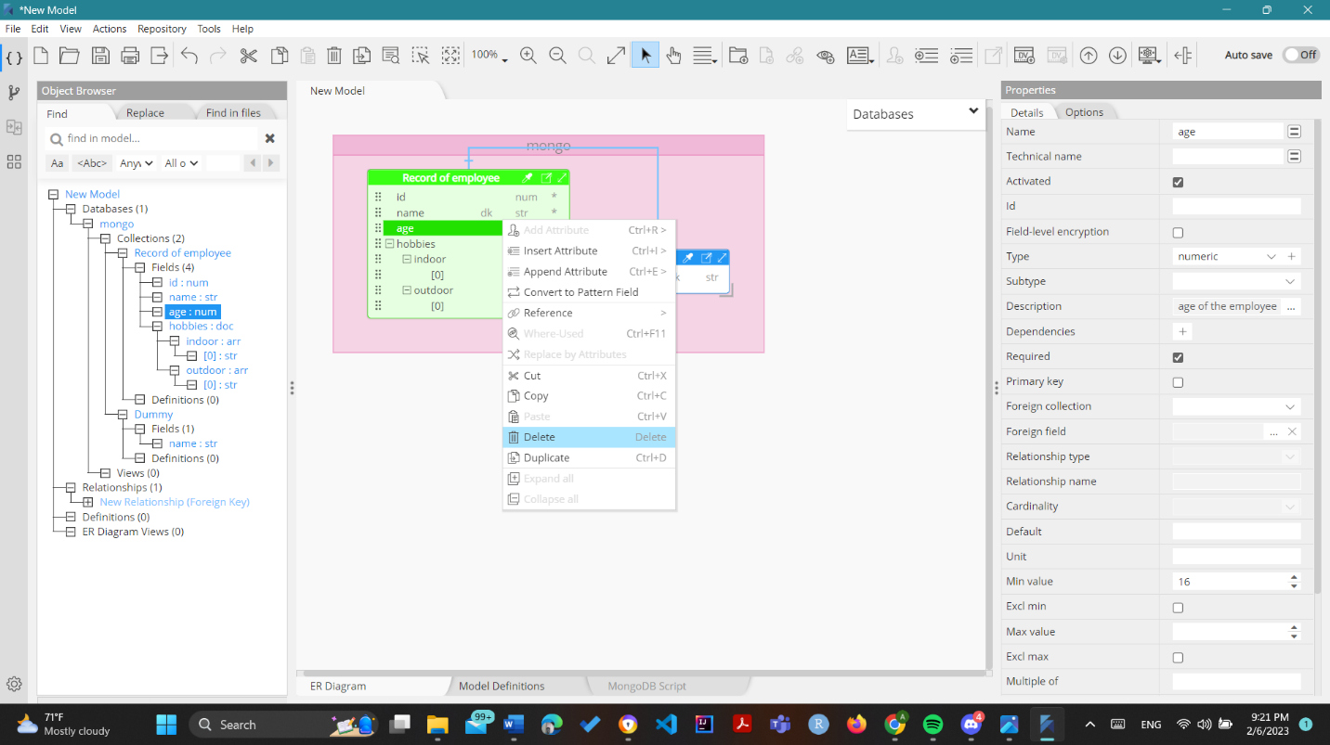

1. Click Remove on the pop up

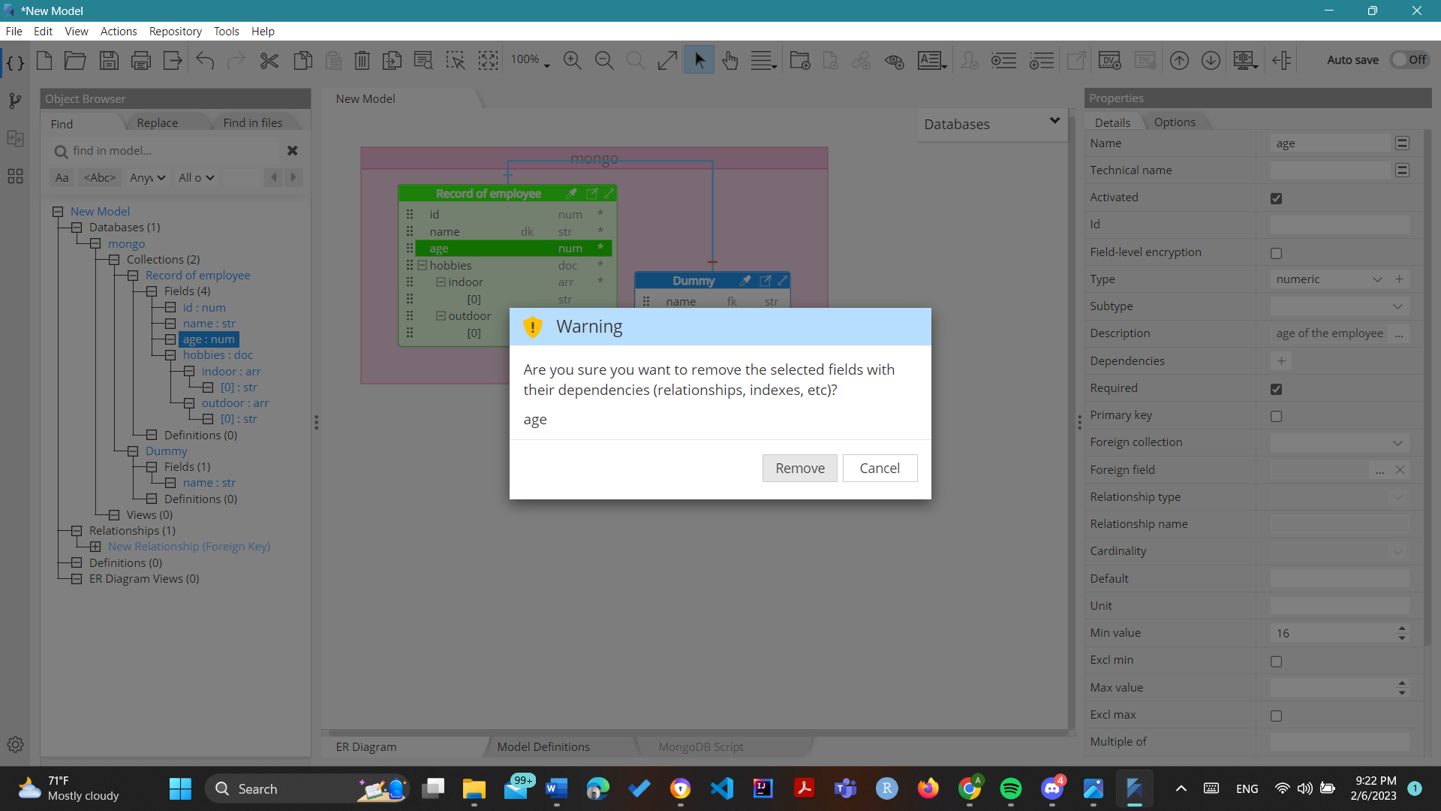

1. Now see in the Record of employee table the age field has been deleted

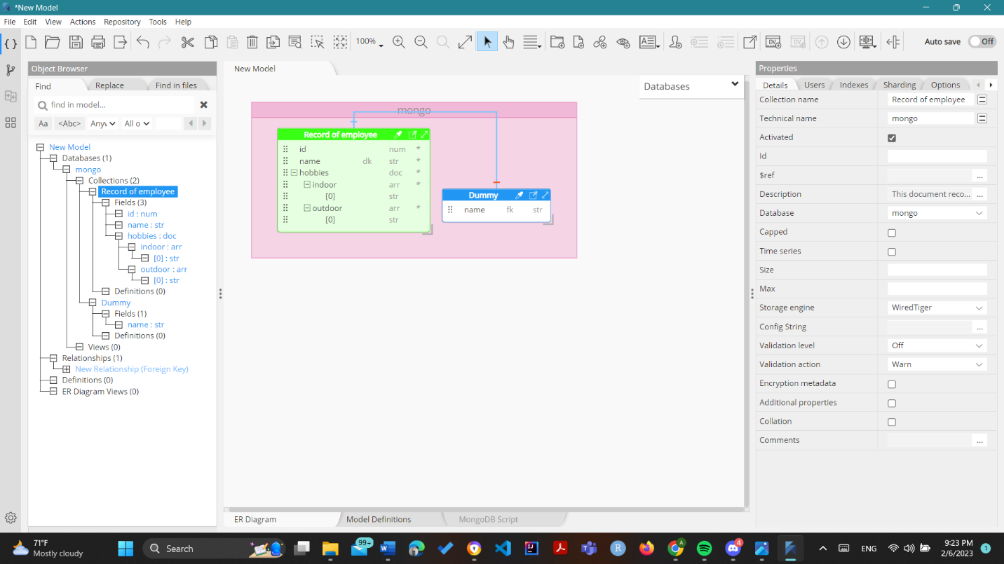

viii. Delete a collection

Note : For this example the dummy collection will be deleted

1. Right click table to be deleted and click delete

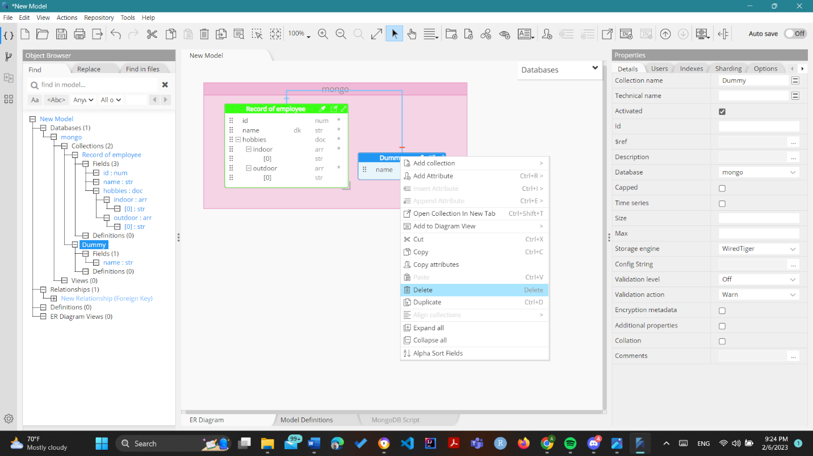

1. Click Remove on the Pop-Up that appears

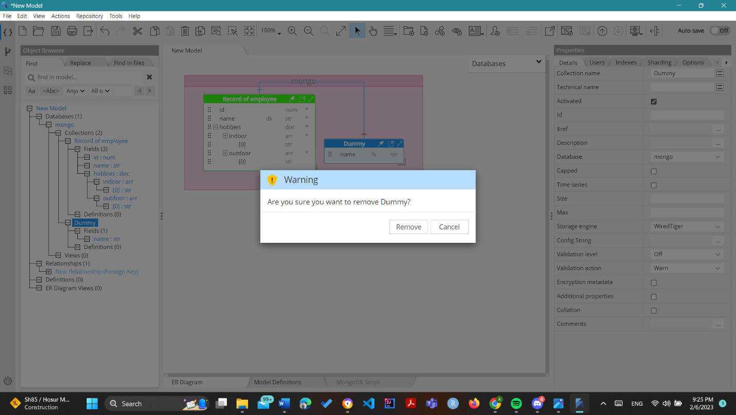

1. Notice that the Dummy table has been deleted

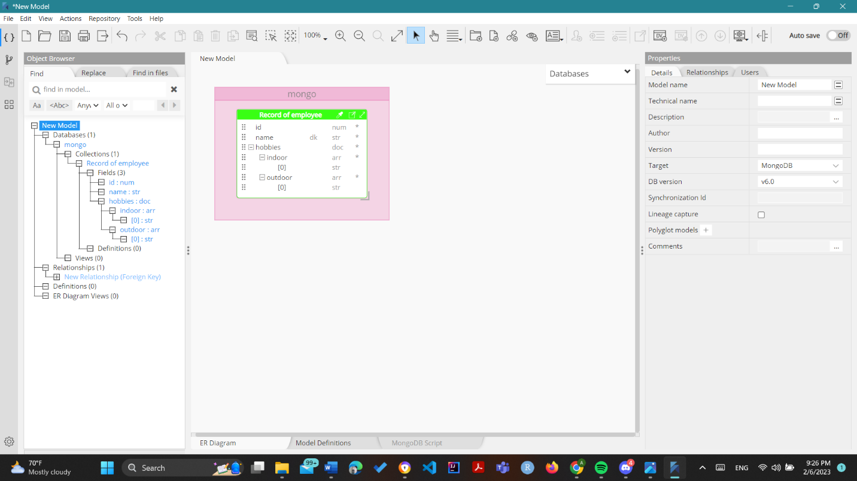

ix. Export as mongodb script – Forward Engineering

1. Select Tools in Menu , Forward-Engineer , MongoDB Script

